Challenge: Shattered Tablet

# Challenge Description :

**Deep in an ancient tomb, you've discovered a stone tablet with secret information on the locations of other relics. However, while dodging a poison dart, it slipped from your hands and shattered into hundreds of pieces. Can you reassemble it and read the clues?**

# Context :

## Analyze this Compiled file, for this one you must keep your eyes peeled as its looking at plain binary, for reconstruction on the HTB flag

# Flag :

* **First Install the files and extract them, Load it up with a decompiler that supports ELF files at least.**
* **I opened it up with IDA Decompiler and went to start on the main function, to look for anything interesting.**
* **I only thing i found was some logic to enter a specific string, that had been messed about with and scattered in random binary locations**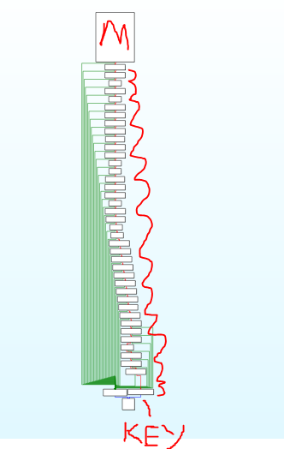
* **The [ M ] at the top represents the main function and the boxes in-between leading downwards towards the [ Key ] each contain a single Characters i need to reconstruct the flag. The Last three boxes at the end is logic for if the flag is correct or not.**
* **Each of the Boxes in-between are also not in-order so i will need to find a pattern to match them.**
* I was finally able to find a way to reconstruct the flag, reading the binary closely you can start to realize they are labeled to be put in order.
* For example a flag would be like : HTB{Ex4mpl3} . And the binary for H will be  **[ rbp+s ] and T will be [ rbp+s+1]**
* **The Reconstruction of the flag wasn't as easy as i hoped, but going slowly one by one i was able to do it.**

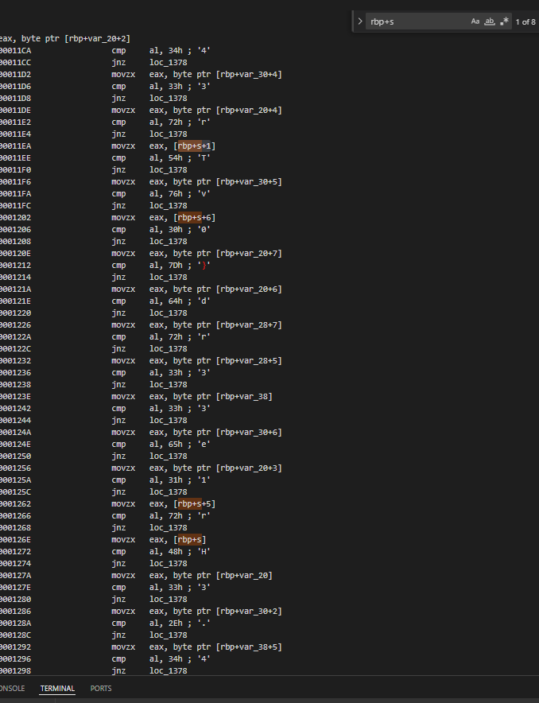

* **The Flag when Constructed should be :**

**HTB{br0k3n_4p4rt...n3ver_t0_b3_r3p41r3d}**